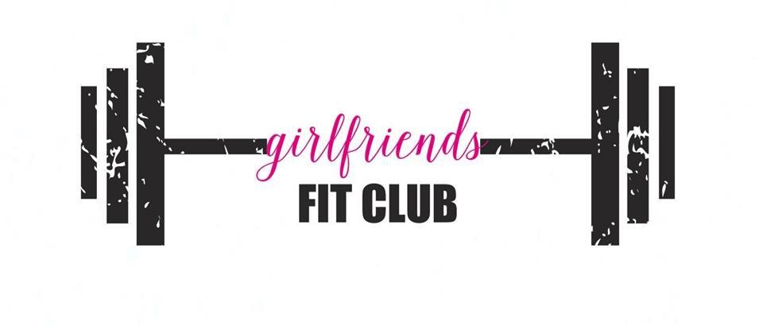
Member Hours of Operation
Monday-Sunday: 5am-9pm
Child Care Hours
Monday-Friday: 8am-1pm
WINTER 2019 CLASS SCHEDULE

Class Levels: B=Basic, I=Intermediate, A=Advance, ALL

Monday | Tuesday | Wednesday | Thursday | Friday | Saturday
8:00am-9:00am  Yoga/Pilates  (ALL)  Bonnie | 8:00am-8:30am  Boot Camp  (ALL)  Carrie | 8:00am-9:00am  Zumba  (ALL)  Rosie | 8:00am-8:30am  Boot Camp  (ALL)  Carrie | 8:00am-9:00am  Barre/Yoga  (ALL)  Bonnie
9:15am-10:15am  Athletic Training  (ALL)  Dawn | 9:15am-10:15am  Strictly Strength  (ALL)  Brittnee | 9:15am-10:15am  Burn & Build  (ALL)  Jennifer | 9:15am-10:15am  Zumba  (ALL)  Regina | 9:15am-10:15am  Athletic Training  (ALL)  Dawn | 9:00am-10:15am  Yin/Yang Flow Yoga  (ALL)  Ria
10:20am-11:20am  Easy Does It  (Toning/Yoga)  (B-ALL)  Bonnie | 10:20am-11:20am  Zumba Gold  (B-ALL)  Regina |  | 10:20am-11:20am  Easy Does It  (Toning/Yoga)  (B-ALL)  Bethany/Jamie |  | 10:45am-11:45am  Groove Fit  (ALL)  Heather
12:00pm-12:30pm  Boot Camp  (ALL)  Carrie | 12:00pm-12:45pm  Yoga  (ALL)  Ria | 12:00pm-12:30pm  Boot Camp  (ALL)  Brittnee | 12:00pm-12:45pm  Yoga  (ALL)  Jamie | 12:00pm-12:30pm  Boot Camp  (ALL)  Carrie
 |  |  |  |  | Sunday
5:30pm-6:30pm  Sculpted Body  (ALL)  Pamela | 5:30pm-6:30pm  Girls Fit Camp  (ALL)  Dawn | 5:30pm-6:30pm  Hot Vinyasa Yoga  (I-A)  Ria | 5:30pm-6:30pm  Girls Fit Camp  (ALL)  Dawn |  | 2:00pm-3:00pm  Girls Fit Camp  (ALL)  Dawn
6:35pm-7:35pm  Yoga  (ALL)  Jamie | 6:35pm-7:05pm  Boot Camp  (ALL)  Carrie | 6:35pm-7:35pm  Groove Fit  (ALL)  Heather | 6:35pm-7:05pm  Boot Camp  (ALL)  Jenn P.

CIRCUIT  Can’t make it in for a scheduled class with one of our instructors? We’ve set up a self-led circuit that you can do anytime there is not a scheduled class in our aerobic room. Options for all levels and days of the week! Questions? Speak with some at the front desk or scan the QR code to link to our YouTube videos! | HOT VINYASA YOGA  Add a little heat to your Yoga with this uniquely designed Hot Yoga class. We gradually warm our Yoga Studio up to 80-85 degrees to relax your muscles for enhanced flexibility. This is a vigorous more athletic approach to Yoga. |  | BURN & BUILD  Made up of athletic drills, short cardio bursts with lower body weight exercises and upper body strength training. These challenging and effective drills are performed back to back to give you a leaner, stronger body...quickly! This workout improves muscle shape and definition and elevates overall fitness goals
BARRE/YOGA  A perfect pairing of yoga and barre. This is a fusion class with mixed elements of pilates, yoga and functional training. In each energizing and targeted workout, you’ll use the barre and exercise equipment such as mini-balls and small hand weights to sculpt, slim and stretch your entire body. This class will start with a warm up and sequence of upper body exercises, moving to the lower body and core. You will end class with yoga which will increase flexibility, balance and leave you feeling rejuvenated and refreshed. | ATHLETIC TRAINING  This class is a mix of aerobic and toning intervals that utilizes both high and low impact chorography with a high level of intensity. Activities will include hi/low aerobics, ply metrics, kickboxing, weights, body bars, bands and any other toys that Dawn can come up with. The class will wrap up with some killer core work to sculpt the abs. |  | GROOVE FIT  Experience the dance floor! GROOVE FIT is a mind-blowing, creative DANCE floor experience infused with functional fitness that equals PURE BLISS! Not only do you get to Dance Your Heart Out in the way that best suits your body and soul, you will also be encouraged to focus on various areas of fitness from your head to your toes. GROOVE FIT is the ultimate fitness fun!
YIN/YANG FLOW YOGA  ​Yin/Yang Flow is a combination of Yin practice, which penetrates deep into connective tissue expanding your flexibility, eliminates energetic blockages, and active Yang practice. This is the more traditional pose practice that develops muscular strength, stamina, and flexibility. For aspiring beginners to advanced practitioners. | 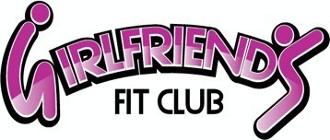 |  | YOGA  While stretching is certainly involved, Yoga is really about developing strength and flexibility and is for the mind and body. This is done through the performance of uninterrupted flow of traditional poses. Leave feeling relaxed and refreshed, ready to go on with your daily schedule.
STRICTLY STRENGTH  This progressive strength training class is perfect to build and tone your full body. Enjoy this muscular workout that will tighten and tone for a lean body. We will use a variety of fitness tools to get a full body workout. | YOGA/PILATES  Fusion of Yoga and Pilates, focusing on strengthening the core and increasing flexibility. Stretching and relaxation techniques are incorporated to help you focus on your mind body connection. |  | SCULPTED BODY  Total body workout featuring cardio bursts and resistance sets for high intensity metabolic response. Emphasis on proper form.
BOOT CAMP  You will do elements of high intensity training and active rest periods giving you the best results with the maximum fat burning effect in only 30 minutes! We modify this class so it fits your individual needs and fitness level! ALL are welcome! | GIRLS FIT CAMP  A super-diverse cardio workout that uses various types of cardio, light and heavy weights, resistance bands, balls, and ropes. The variety will challenge your muscles in multiple dimensions while maximizing overall benefits. Between each interval there will be some awesome core work. |  | EASY DOES IT (gentle cardio, toning, yoga)  A combination of gentle Cardio/Toning/Yoga focusing on low impact movements. During this class you will be building muscle and balance while improving range of motion, flexibility and strength. Perfect for ladies who are “new” to exercise or are simply looking for a low impact option.
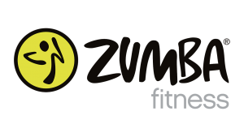  A fusion of Latin and International music/dance themes that create a dynamic, exciting, and based on the principle that a workout should be “FUN AND EASY TO DO.” The routines feature aerobic/fitness interval training with a combination of fast and slow rhythms that tone and sculpt the body. |  | 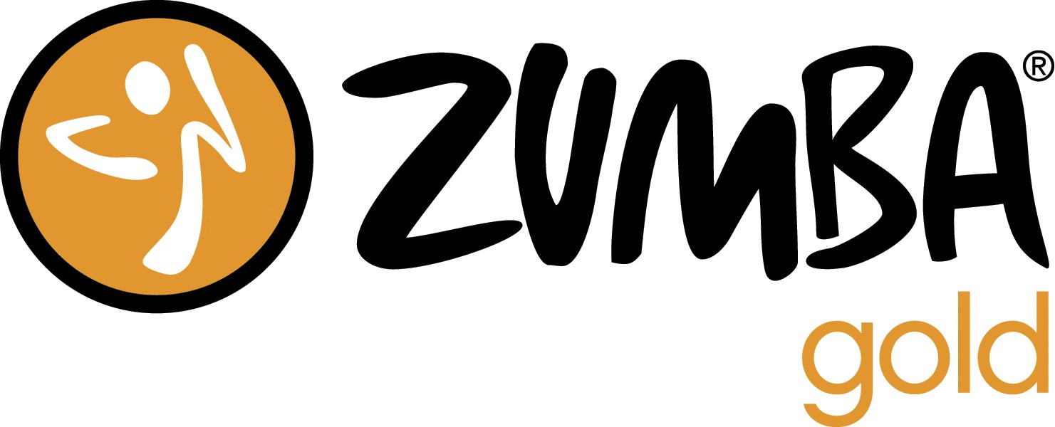  For active older adults who are looking for a modified Zumba class that recreates the original moves you love at a lower-intensity. This cardio fitness dance party is set to mostly Latin rhythms. It is for anyone looking for a modified Zumba class at a lowered intensity. Zumba Gold features easy to follow choreography that focuses on balance, range of motion, and coordination.
Be sure to check out our self-led circuit!
Questions? Scan the QR code available at each station for instructions.

GUEST HOURS:
Monday – Thursday 8-1 & 5-8
Friday 8-1 & Saturday 8-12
Call today for a tour 616-399-9086

